**User Manual of Login Page**

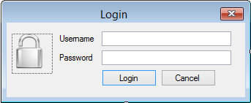

* **This is the Login page through which user can log in by entering username and password.**